John Mellencamp – Hurts So Good
Original key: A Us: Same

[INTRO]
2 bars drums; 2 bars guitar, 8 bars riff

VERSE
A | E | f#m | D [2x]
A | E
^^^ break, anticipate next chord
A | E | f#m | D

CHORUS
A | E | A | E
D f#m | D | E ...to lick
^^^ anticipate

BRIDGE 2:09 Smear up with organ
D | A | D | *f#m *A * anticipate
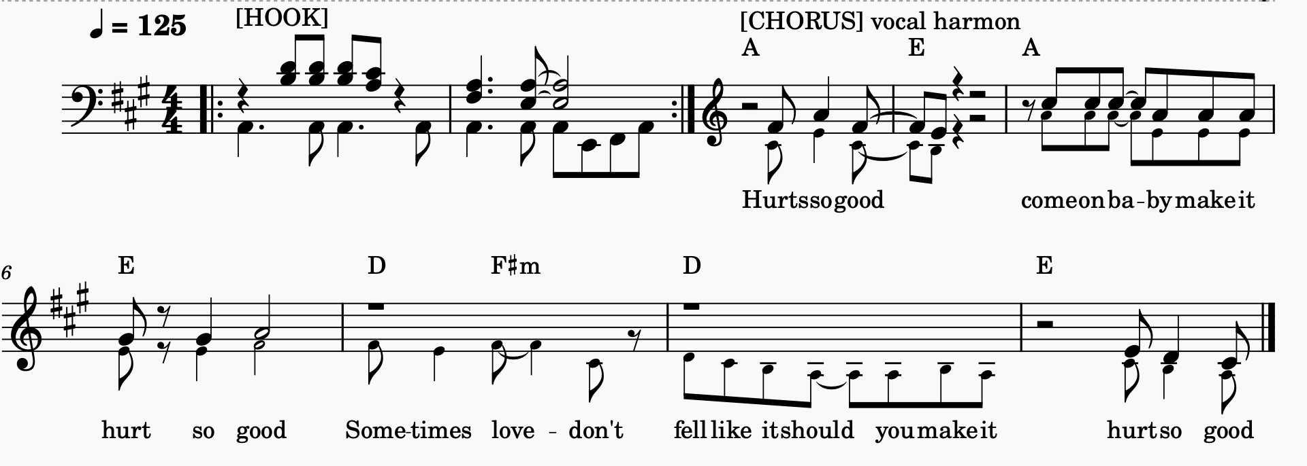
D | *A | E (four bars)

